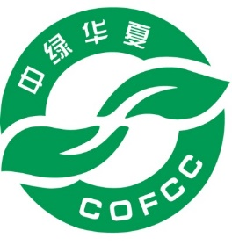
报价所需基本信息
Information for Quoting for Chinese Organic Certification

中绿华夏有机食品认证中心
China Organic Food Certification Center
Address: No.59 Xueyuan South Road, Haidian District, Beijing Postcode: 100081
Website：www.ofcc.org.cn E-mail：wenpeng.you@aco.net.au

1. Basic Information about Applicant
Company Name
Contact person |  |  |  |  |  |  | Mobile
Postal code |  |  | Tel |  |  |  | Fax
E-mail |  |  |  |  | Website

2. Basic Information about Products
# | Product name |  | Trade name | Expected yield (ton) | Projected Sale (Currency)
Facilities involved in production and processing of the above products
Farms | Name | Address |  |  | Acreage
Processing

